HYDRA-WELD 400-10
HYDRAULICALLY-DRIVEN
DC WELDER & AC GENERATOR
BY

120 / 240V  60 Hz  10000 Watts | 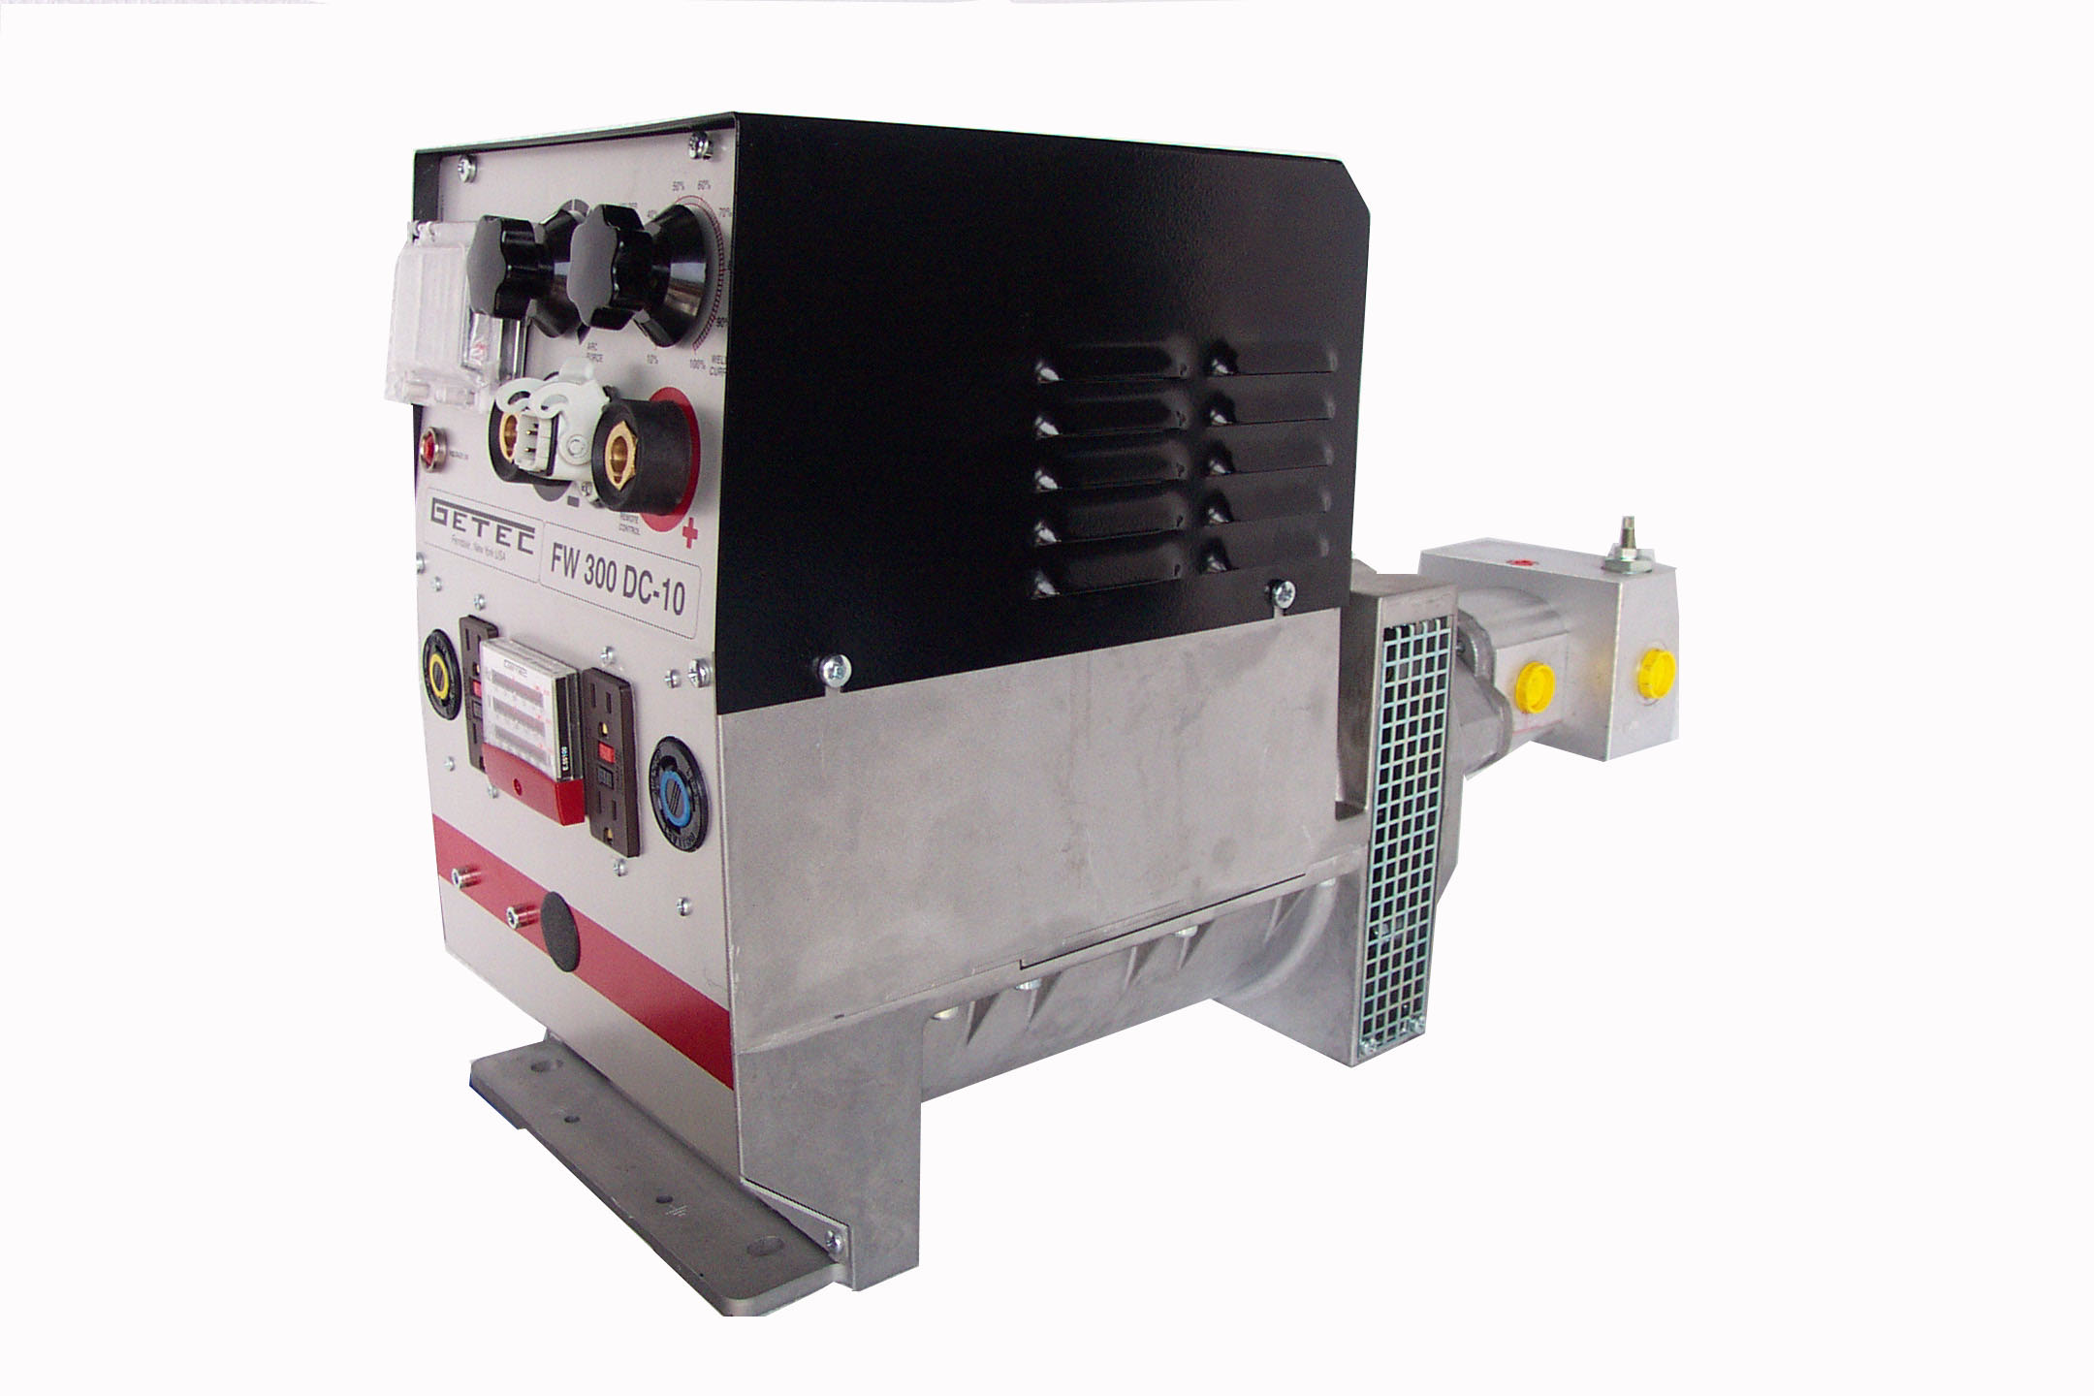 | 400 Amp  DC

QUALITY FEATURES
400 DC Amps | Continuous Fine Control
70% Duty Cycle | Locking Weld Receptacles

SPECIFICATIONS
Flow | = 24 GPM | AC Volts | = 120 or 120 / 240
Pressure | = 2300 PSI Max | Generator Output | = 10000 Watt
Frequency | = 60 Hz | Amps | = 400 DC Amps
Weight | = 162 Lbs | Strike Voltage | = 82 VDC Adjust
Weld Voltage | = 22 – 28 VDC | Dimensions(inches) | = 11W*17H*29L

