HYDRA-WELD 250-5.5
HYDRAULICALLY-DRIVEN
DC WELDER & AC GENERATOR
BY

120 / 240V  60 Hz  5500 Watts | 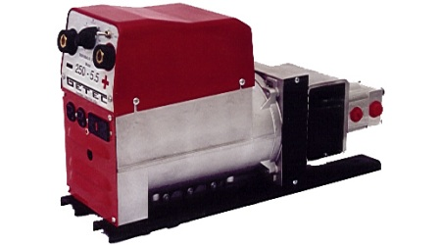 | 250 Amp  DC

QUALITY FEATURES
250 DC Amps | 7 Step – 3 Range
70% Duty Cycle | Locking Weld Receptacles

SPECIFICATIONS
Flow | = 20 GPM | Volts | = 120 or 120 / 240
Pressure | = 2200 PSI Max | Generator Output | = 5500 Watt
Frequency | = 60 Hz | Amps | = 250 DC Amps
Weight | = 138 Lbs | Strike Voltage | = 82 VDC
Weld Voltage | = 22 – 28 VDC | Dimensions (inches) | = 8W*14H*27L

