HYDRA-WELD 225-4
HYDRAULICALLY-DRIVEN
DC WELDER & AC GENERATOR
BY

120 / 240 V  60 Hz  4200 Watts | 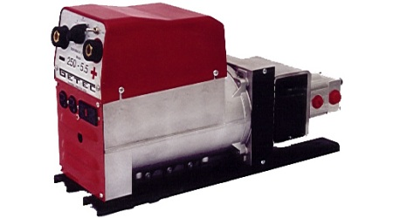 | 225 Amp  DC

QUALITY FEATURES
225 DC Amps | 7 Step – 2 Range
70% Duty Cycle | Locking Weld Receptacles

SPECIFICATIONS
Flow | = 20 - 40 GPM | Volts | = 120 or 120 / 240
Pressure | = 2000 PSI Max | Generator Output | = 4200 Watt
Frequency | = 60 Hz | Amps | = 225 DC Amps
Weight | = 115 Lbs | Strike Voltage | = 82 VDC
Weld Voltage | = 22 – 28 VDC | Dimensions(inches) | = 8W*14H*30L

