GETEC Hydraulic Welder Generators

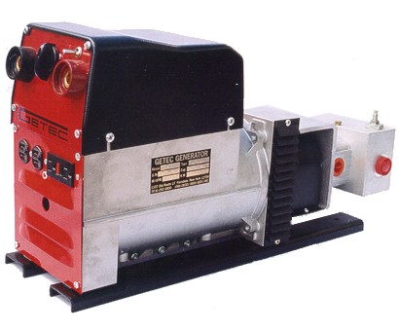

Welder Specifications
Model | 200-4 | 225-4 | 250-5.6 | 300-16 | 400-16
Weld Amps | 200 | 225 | 250 | 300 | 400
Strike Voltage | 65-75 | 75 | 75 | 88 | 88
Weld Voltage | 23-30 | 21.6 - 28 | 20-29 | 21-32 | 21-36
Type | DC | DC | DC | DC | DC
Speed (RPM) | 3600 | 3600 | 3600 | 3600 | 3600
Insulation Class | H | H | H | H | H
Protection | Thermal | Thermal | Thermal | Thermal | Thermal
Duty | 45% | 65% | 65% | 70% | 70%
Drive Power | 10 HP | 18 HP | 21 HP | 28 HP | 33 HP

